**LASER LIGHT SECURITY SYSTEM**

APPLIED PHYSICS PROJECT



SUBMITTED TO:

**Dr. M RIZWAN AMIRZADA**

FROM:

**SADIA(33730),**

**M. ABDULLAH ARBAB(19222),**

**MANSOOR AHMAD(31742),**

**AFAF NOOR(33268),**

**AHMED NIAZ(33813)**

SUBMISSION DATE:

**26-12-2023**

**National University of Modern Languages Islamabad**

**Contents**

**LASER SECURITY SYSTEM PROJECT 2**

**1.1 PROBLEM 2**

**1.2 SOLUTION 2**

**DEVICE 2**

**2.1 INTRO 2**

**2.2 COMPONENTS 3**

**2.2.1 Light Dependent Resistor (LDR): 3**

**2.2.2 BC547 NPN Transistor: 3**

**2.2.3 Buzzer: 3**

**2.2.4 2.2k ohm Resistor: 3**

**2.2.5 Power Source (9V Battery): 4**

**CIRCUIT 4**

**3.1 Circuit Configuration 4**

**3.1.1 Power Supply: 4**

**3.1.2 Light Dependent Resistor (LDR): 4**

**3.1.3 2.2k ohm Resistor: 4**

**3.1.4 BC547 NPN Transistor: 5**

**3.1.5 Buzzer: 5**

**WORKING 5**

**4.1 Light Dependent Resistor (LDR): 5**

**4.2 BC547 NPN Transistor: 5**

**4.3 Buzzer: 5**

**4.4 Laser Beam Interruption: 5**

**4.5 Buzzer Activation: 6**

**SIMULATION 6**

**FIGURE 5.1 : SYSTEM WITHOUT INTERUPTION 6**

**DEPLOYMENT 7**

**Museums and Galleries: 7**

**Military Installations: 8**

**Abstract 8**

# LASER SECURITY SYSTEM PROJECT

## 1.1 PROBLEM

Security breaches and unauthorized access have been persistent challenges, especially in areas with limited visibility or traditional surveillance blind spots. Conventional security measures often fall short in providing timely alerts, leaving valuable assets vulnerable to intruders. The need for a proactive and cost-effective solution to detect and address these security concerns prompted the development of advanced security systems.

## 1.2 SOLUTION

In response to the challenges posed by unauthorized access and security breaches, the Laser Light Security System emerged as an innovative solution. This system leverages the interruption of a laser beam to trigger an immediate alert through a buzzer, serving as a reliable intrusion detection mechanism. The Laser Light Security System offers a practical and real-time approach to fortifying security, especially in areas where traditional measures prove inadequate. Its cost-effectiveness, coupled with the ability to function in diverse environments, positions it as a valuable asset in safeguarding premises and assets from potential threats.

# DEVICE

## 2.1 INTRO

The Laser Light Security System represents a cutting-edge solution to contemporary security challenges. Leveraging advanced laser technology, this innovative device is engineered to detect and alert against unauthorized access and security breaches. Its fundamental operation involves the interruption of a laser beam, triggering an immediate response through a built-in buzzer. The system's design prioritizes cost-effectiveness and efficiency, making it a valuable asset in fortifying security, especially in areas where traditional measures may be insufficient. This introductory device seamlessly integrates into diverse environments, offering a proactive approach to safeguarding premises and assets.

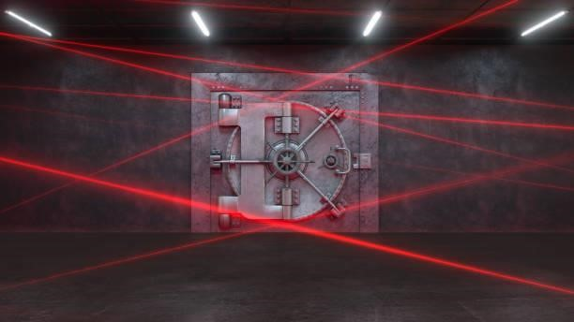

FIGURE 2.1 : LASER SECURITY SYSTEM FOR LOCKERS

## 2.2 COMPONENTS

The Laser Light Security System comprises key components that collectively contribute to its efficient operation:

### 2.2.1 Light Dependent Resistor (LDR):

* The LDR is a crucial sensor that detects changes in light intensity. In this system, it plays a pivotal role in responding to alterations in the laser beam caused by potential intruders.

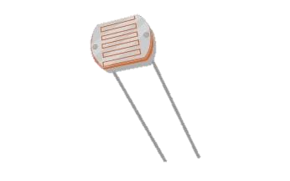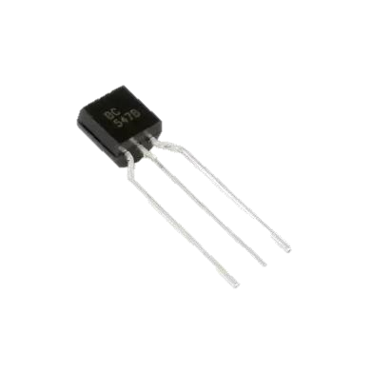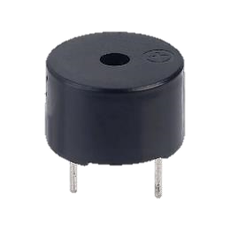

### 2.2.2 BC547 NPN Transistor:

* The BC547 NPN transistor acts as a switch in the circuit. When activated by the LDR, it enables the flow of current, facilitating the alarm-triggering mechanism.

### 2.2.3 Buzzer:

* The buzzer serves as the audible alert component. When the laser beam is interrupted, the buzzer is activated through the transistor, providing an immediate and noticeable alert.

### 2.2.4 2.2k ohm Resistor:

* The resistor is strategically placed in the circuit to regulate the flow of current, ensuring the proper functioning of the system and contributing to its overall reliability.

### 2.2.5 Power Source (9V Battery):

* The 9V battery powers the entire system, making it portable and independent of external power sources. This ensures continuous surveillance and security.

# CIRCUIT

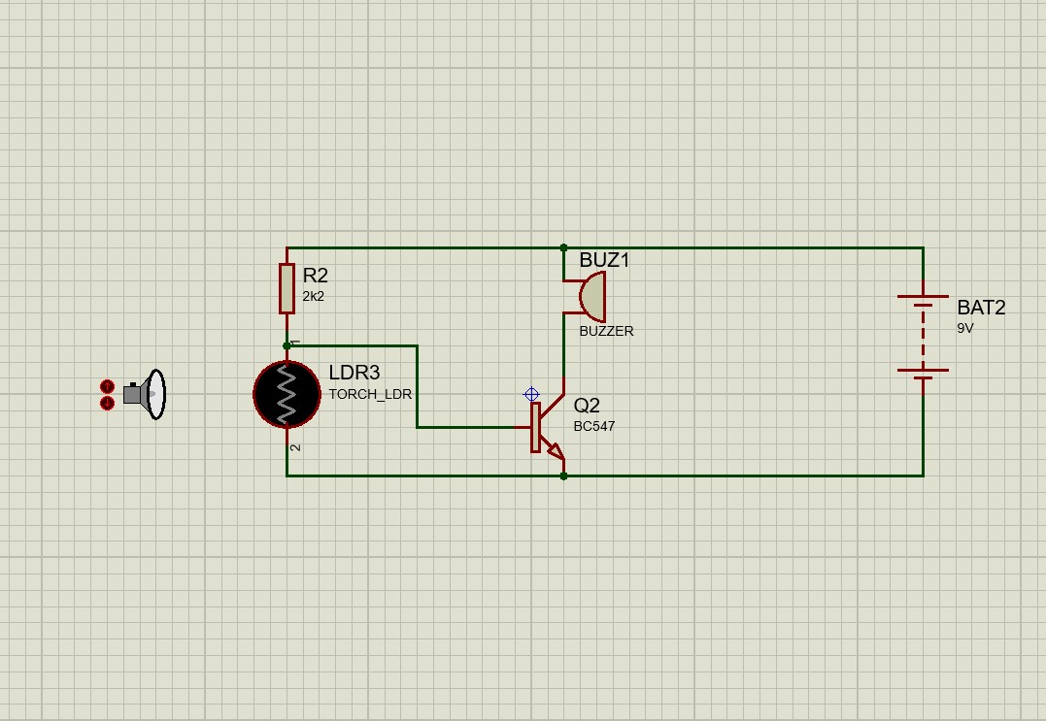

## 3.1 Circuit Configuration

### 3.1.1 Power Supply:

* Connect the positive terminal of the 9V battery to the positive rail of the breadboard.
* Connect the negative terminal of the 9V battery to the negative rail.

### 3.1.2 Light Dependent Resistor (LDR):

* Connect one leg of the LDR to the positive rail.
* Connect the other leg of the LDR to the base (B) of the BC547 transistor.

### 3.1.3 2.2k ohm Resistor:

* Connect one end of the resistor to the base (B) of the BC547 transistor (same point as the LDR connection).
* Connect the other end of the resistor to the negative rail.

### 3.1.4 BC547 NPN Transistor:

* Connect the emitter (E) of the BC547 transistor to the negative rail.
* Connect the collector (C) of the BC547 transistor to one terminal of the buzzer.

### 3.1.5 Buzzer:

* Connect the other terminal of the buzzer to the positive rail.

# WORKING

The Laser Light Security System operates on a straightforward yet effective principle involving the interaction of its key components:

## 4.1 Light Dependent Resistor (LDR):

The LDR is sensitive to changes in light intensity. In the system, it is positioned to receive the laser beam. When the beam is uninterrupted, the LDR's resistance is low.

## 4.2 BC547 NPN Transistor:

Connected to the LDR, the BC547 NPN transistor acts as a switch. In the presence of a continuous laser beam, the LDR allows current to flow through the transistor's base-emitter junction, keeping the transistor in a conducting state.

## 4.3 Buzzer:

The buzzer is connected to the collector of the BC547 transistor. As long as the laser beam is uninterrupted, the transistor conducts, completing the circuit, and the buzzer remains silent.

## 4.4 Laser Beam Interruption:

When an object or an intruder disrupts the laser beam, the LDR's resistance increases. This change prevents current flow through the base-emitter junction of the transistor, causing it to transition to a non-conducting state.

## 4.5 Buzzer Activation:

With the transistor no longer conducting, the circuit is broken, activating the buzzer. The buzzer produces an audible alert, indicating the interruption of the laser beam and potential unauthorized access.

In summary, the system's functionality hinges on the LDR's ability to sense changes in light intensity, coupled with the transistor's role in regulating current flow. The laser beam interruption triggers a swift response, alerting individuals to potential security breaches through the audible alert provided by the buzzer.

# SIMULATION

• **Before any interruption**, the Laser Light Security System remains in standby, with the laser beam ensuring the continuous flow of current through the circuit, maintaining a silent state for the buzzer.

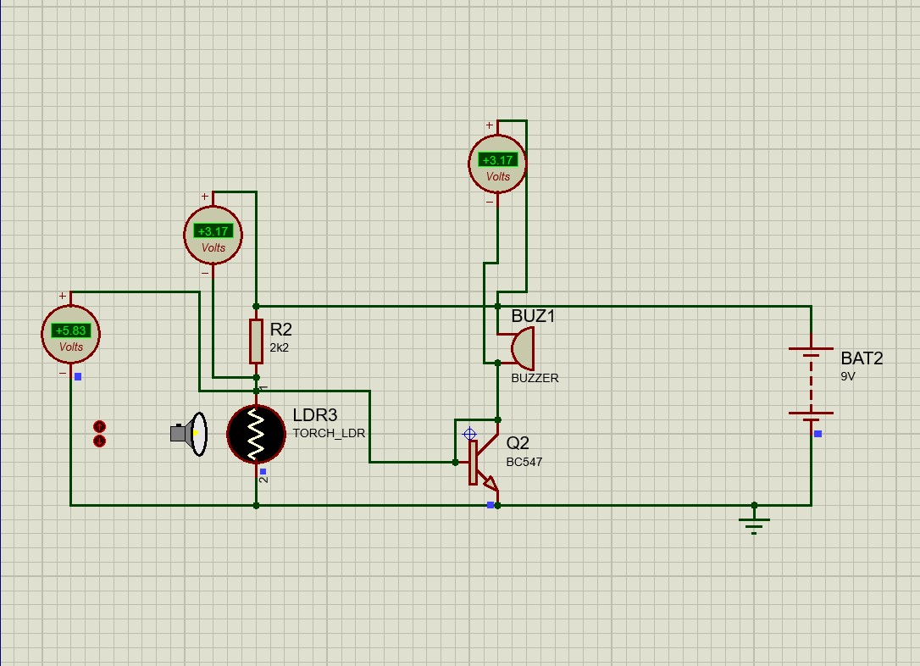

## FIGURE 5.1 : SYSTEM WITHOUT INTERUPTION

• **Upon interruption** of the laser beam, the Light Dependent Resistor's increased resistance disrupts the current flow, causing the BC547 transistor to cease conducting. This triggers the activation of the buzzer, providing an immediate audible alert signalling a potential security breach.

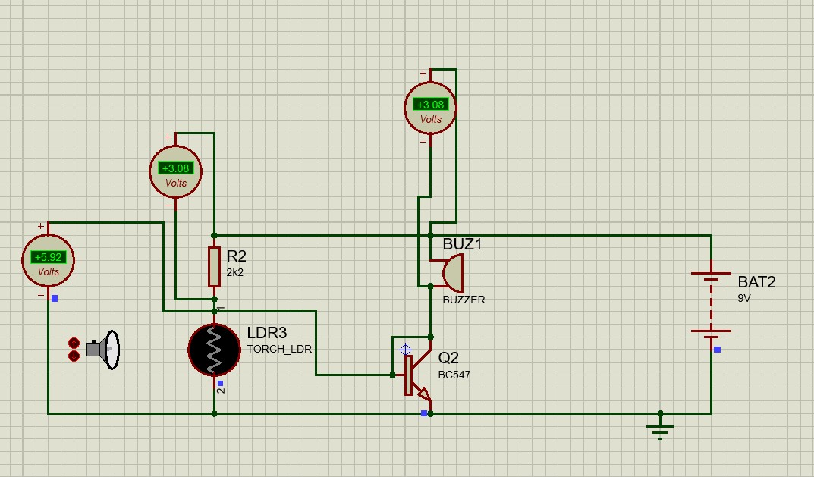

FIGURE 5.2 : SYSTEM ON INTERUPTION

# DEPLOYMENT

The Laser Light Security System can be employed in various environments and scenarios where intrusion detection and security monitoring are crucial. Here are some specific places where this system can be utilized:

Museums and Galleries:



Museums, with their priceless artifacts and culturally significant exhibits, can greatly benefit from the implementation of the Laser Light Security System. The Laser Light Security System provides continuous surveillance, offering protection even during non-operational hours or when the museum is closed to the public.

Military Installations:

Deploying the Laser Light Security System in military installations is a strategic move to fortify the security infrastructure of these crucial and sensitive sites. This innovative system offers a multi-faceted approach to safeguarding military facilities. By strategically placing laser modules around restricted areas and sensitive zones, the system provides real-time intrusion detection. The Laser Light Security System ensures that only authorized personnel have access to high-security locations, preventing unauthorized entry or tampering. Its integration with surveillance cameras and other security measures enhances the overall situational awareness of military personnel.



# Abstract

The Laser Light Security System is an innovative project designed to enhance security measures through the implementation of laser technology. The system utilizes a Light Dependent Resistor (LDR), a BC547 NPN Transistor, and a buzzer to detect and alert against unauthorized access or security breaches. In its standby state, the continuous laser beam maintains a silent mode for the buzzer. However, upon interruption of the laser beam, the system swiftly responds by activating the buzzer, providing a real-time audible alert. This project aims to offer a cost-effective and efficient solution for intrusion detection, contributing to the advancement of security systems in various environments.